whatsUrSay Use-Case Diagram:

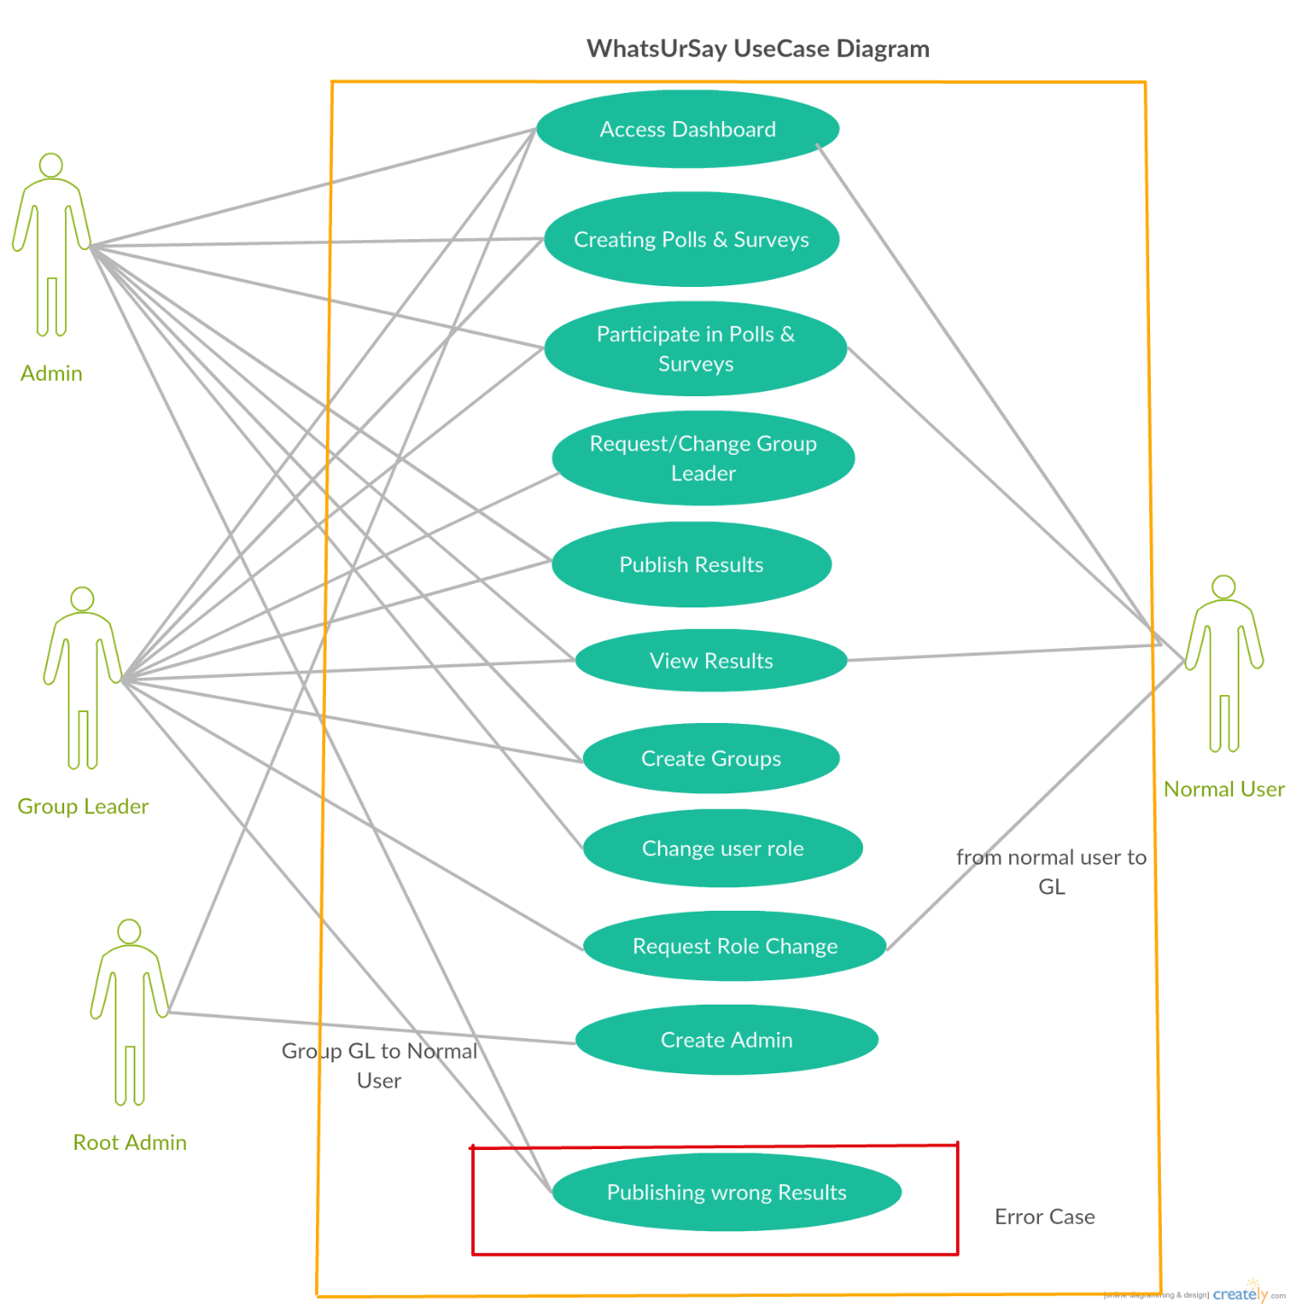

WhatsUrSay Class Diagram:

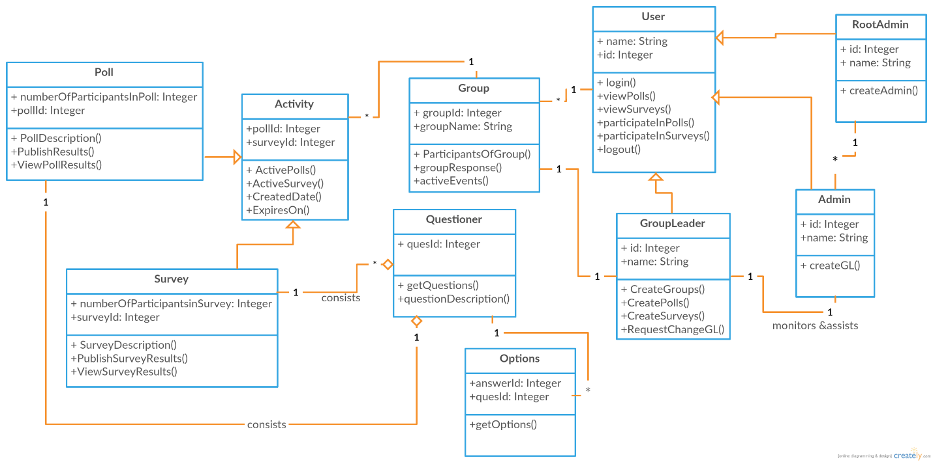

WhatsUrSay Sequence Diagram

